**Project Name:** BMI Calculator

**Github Link:** https://github.com/projectsforstudents2022/BMI_Calculator.git

**Why was this project created?**

The BMI Calculator App is a piece of software that, with just one click, eliminates the need to manually calculate and find someone's BMI for additional hours. This software gives us all the information in both standards that is not provided by other apps. The main goal is to maintain health. It keeps both the American standard and Indian standard in it. The BMI App provides all the information we need, makes recommendations for our health, and advises us on what foods to eat and stay away from. We can find out if we are overweight or underweight by entering our height and weight.

**What problem is it solving?**

The BMI Calculator App is a piece of software that, with just one click, eliminates the need to manually calculate and find someone's BMI for additional hours. This software gives us all the information in both standards that is not provided in other apps. It maintains both the American standard and the Indian standard.

**Entire explanation of project**

* **PROPOSED APPROACH**

Utilizing the Microsoft Azure Cloud platform, our project intends to launch a website. In software and online development, deployment refers to the act of sending changes or updates from one deployment environment to another. Applications, modules, updates, and patches are delivered from developers to users through the deployment process. The techniques used by developers to create, test, and deploy new code will have an impact on how quickly and how well a product can adapt to changes in customer preferences or requirements. The language used to describe how Web pages are presented, including their colors, layout, and fonts, is called CSS. It enables the presentation to be adjusted for use on many sorts of devices, including printers, tiny screens, and huge screens. Any XML-based markup language can be used with CSS, which is independent of HTML. It is multifunctional software. However, we have chosen a symmetric approach out of simplicity.

* **RESULT**

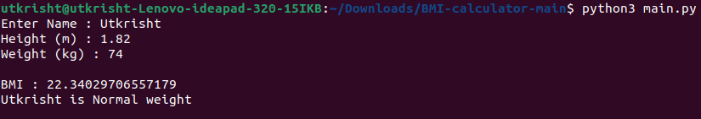

**CONCLUSION**

The project's development has led to the following inferences. The effectiveness of the system is increased via automation. When compared to the current system, it offers a user-friendly graphical interface that is superior. Depending on their permissions, it grants the authorized users the proper access. It successfully gets around the temporal complexity. Information updating gets much simpler. The System can be modified appropriately in the future, if that becomes necessary.